**System Request**

**Project sponsor:**

Student Recreation Center

**Business Needs:**

Due to increasing registration and workload, a new system is required. It would enable us to get the work done with greater efficiency and fewer wages. The new system would help SRC in Count Sheet, Locker Registration, Online Payment, TV on and off system, and integration of a single website. Currently, SRC uses paper count sheets to track the number of people in each section. Instead of using paper, we could use a small application so that we can input our data and it automatically save to the database. We could also create one website that customers would go to, for all the schedules, to register for different things and make payments from the website. And finally, we could set an auto timer to all the TV’s so that it would turn on and off automatically at the set time.

**Business Requirements:**

The functionality that the system should have is listed below:

* Allow for Member Self-registration
* Locker rental Email notification to the members
* Count sheet automatically saved to the database
* Pay online using the website
* SRC online account for each member
* All TV’s turn on and off simultaneously

**Business Value:**

Expected value to be gained from the system

* Improved customer satisfaction
* Better record-keeping
* Reduction in the paper cost of about $8,000 every year
* The decrease in wages is about $825 every year
* Increase in revenue of about $24,000 every year

**Special Issues or Constraints:**

* Project cost must be within budget
* It must be finished within a given time

**The Arsenal**

**Vision (Small Project)**

Version 1

Revision History

|  |  |  |  |
| --- | --- | --- | --- |
| **Date** | **Version** | **Description** | **Author** |
| 09/09/2019 | 1 | Initial draft | Brent Hedden |
| 9/23/2019 | 1.1 | Edited and Appendix A added | The Arsenal |
|  |  |  |  |
|  |  |  |  |

**Table of Contents**

1. Introduction 3

1.1 References 3

2. Positioning 3

2.1 Problem Statement 3

2.2 Product Position Statement 3

3. Stakeholder and User Descriptions 3

3.1 Stakeholder Summary 3

3.2 User Summary 3

3.3 User Environment 3

3.4 Summary of Key Stakeholder or User Needs 3

3.5 Alternatives and Competition 3

4. Product Overview 3

4.1 Product Perspective 3

4.2 Assumptions and Dependencies 3

5. Product Features 3

6. Other Product Requirements 3

Vision (Small Project)

# **1.** **Introduction**

The purpose of this document is to provide an overview and analysis of the issues that the Student Recreation Center is having. The Arsenal, Inc. will be providing potential solutions to these listed issues.

## **1.1** **References**

McHugh, R. (2019, May 22). The True Price of Storing Documents In an Office. Retrieved from <https://www.recordnations.com/2017/02/price-you-pay-to-store-documents-in-office/>

# **2.** **Positioning**

## **2.1** **Problem Statement**

|  |  |
| --- | --- |
| The problem of | Reporting of data collection |
| affects | Management and decision-makers |
| impacts of which is | Data is collected, but nothing more is done with it |
| a successful solution would be | Be able to take action based on realistic data |

## **2.2** **Product Position Statement**

|  |  |
| --- | --- |
| For | Employees of the Student Recreational Center |
| Who | Efficiently within the Facility needs |
| The (product name) | is a website and user interface |
| That | The product will increase security and decrease manual entries |
| Unlike | Previous models |
| Our product | Free and will be on UofL servers. |

# 

# **3.** **Stakeholder and User Descriptions**

The main stakeholders that are affected by the issues presented will be all employees of the SRC, UofL, and members of the SRC. The employees' main requirement is to create a more efficient and organized environment to work in. Our objective with the employees is to make it easier for them to keep records for specific functions they are trying to implement. This will also make it easier for management for the SRC in order to generate more reports and create a better workflow.

For UofL, the goal is to make the SRC something that will stand out to not only potential members but also to potential students looking to attend UofL. Making the SRC appear as its own entity instead of simply a branch of the college could possibly increase profit and decrease the cost to the university. For students, it’s all about giving them the best experience possible. Although they may benefit the least from the implementations, they could potentially benefit from the effects of the changes we are looking to make. Other stakeholders include maintenance companies and possible developers for a website or app.

## **3.1** **Stakeholder Summary**

|  |  |  |
| --- | --- | --- |
| Name | Description | Responsibilities |
| SRC Employees | These individuals are the targeted users that will be using the new implementations to their already existing systems. | Their role is to test and implement the systems into their everyday activities to provide feedback for quality control. |
| SRC Management | SRC management will be listening to our iterations to provide us with directions to improve our vision of the new systems. | Their role is to approve the appropriate changes and suggestions made by us to improve their existing systems. |
| University of Louisville | UofL is the governing body that approves the changes that will be made to the university. | Their role will be to ensure that the systems will create a positive impact on the SRC and the university as a whole. |
| SRC Members | The members represent the individuals that won’t be directly affected by the changes, but potentially can be in the future. | Their role will be to populate the reports with data whether it be for the locker rentals, memberships, and engagement. |
| Maintenance Companies | Maintenance companies represent an outside entity that handles the maintenance of equipment. | Their role is to also benefit from automated systems that include the equipment and television power control. |
| Developers | Developers represent the maintenance and upgrading of the website or app. | Their role is to take and learn the new system and maintain it in order for it to run in the most efficient way possible. |

## **3.2** **User Summary**

|  |  |  |  |
| --- | --- | --- | --- |
| Name | Description | Responsibilities | Stakeholder |
| SRC Members | They represent the user data that will be collected for different reports that will be generated throughout the entire process. They allow the SRC to see how many people are in a specific area and have information stored the connects to their locker rentals and membership fees. | Their responsibility as a user is to populate the reports using normal functions. | SRC Employees |

## 

## **3.3** **User Environment**

The SRC currently relies heavily on the use of paper with all of its systems whether it be locker rentals, memberships, and other records they keep. There is nothing wrong with using paper, however, using it creates a larger probability of losing and mislabeling information that is key for the SRC. There is not a lot of people involved with completing specific tasks, typically each task is completed by only one individual. This isn’t really the problem as much as the time it takes to complete the task. Something as simple as looking for someone’s name within a stack of paper takes one minute to a minute and a half. This may seem insignificant, but can be decreased drastically.

A unique environment constraint that SRC employees deal with is the inconsistent nature of a gym. Tracking where all members can be very difficult because everyone does not have the same workout plan each day. These factors can change day-by-day which makes it hard to track such a dynamic environment. Currently, we have no knowledge of the system platforms and applications being used by the SRC for their database purposes, they seem to only use paper. They do, however, use applications for their maintenance that can be integrated with the new systems that we create that can be collaborated on.

## **3.4** **Summary of Key Stakeholder or User Needs**

|  |  |  |  |  |
| --- | --- | --- | --- | --- |
| Need | Priority | Concerns | Current Solution | Proposed Solutions |
| Increased Employee Productivity | 4 | Nothing guarantees an increase in employee productivity. | Assigning more employees to specific tasks on a shift. | Having fewer people on a shift and assigning more tasks to individuals. |
| Decrease or eliminating paper | 1 | SRCmay not want to drift away from an existing method. | Using paper to keep track of records for members of the SRC. | Using an electronic database system that can keep track of all of these specific records. |
| Creating an independent website | 5 | UofL may not want to fund an independent website. | The SRC “website” is a section of the university's main website. | Creating a website separate from the university's main website. |
| Maintenance Systems | 3 | New systems may not integrate with the current maintenance system. | They currently use their own maintenance system. | Integrate our system with the current maintenance system to make it more efficient. |
| Online Payments | 6 | This will have a cost behind it and many people may not trust it. | Currently, they show no interest in using an online payment system. | Implement an online payment system that makes it more convenient to pay off locker and membership fees. |
| Count Sheets | 2 | These need to be as accurate as possible and is highly susceptible to human error. | They go around and enter this data by hand on paper. | Create a more efficient way to keep track of how many members are in a specific area electronically. |

## **3.5** **Alternatives and Competition**

* The main competitor we are facing is maintaining the status quo. The phrase if it isn’t broke don’t fix it can apply here. The concern here is that the stakeholders will find all of these potential implementations redundant, overbearing, and overall, costly and will steer them away from making any of these changes. They have been doing it the same way for such a long time, that we are afraid that they will hear us out, but ultimately keep it as a suggestion and remain with the same system. Their current system works, however, we have the potential to upgrade it and lead it to many great improvements.

# **4.** **Product Overview**

[This section provides a high-level view of the product capabilities, interfaces to other applications, and system configurations. This section usually consists of two subsections, as follows:

• Product perspective

• Assumptions and dependencies ]

## **4.1** **Product Perspective**

The integration of a Single Website that allows online payment, opens the opportunity for the organization to engage in e-commerce to sell SRC branded things and even allow registrations for classes and activities online.

## **4.2** **Assumptions and Dependencies**

They are willing and able to pay for a website

Only want a product that could satisfy their needs.

It could increase their revenue and reduce wage expenses.

# **5.** **Product Features**

* The product would be open-source.
* Data entry is friendly.
* The online system might be a very good way to increase productivity and allow customers to get membership from anywhere on the website.
* Increased productivity could also reduce wage expenses for SRC because they could reduce unnecessary staff.

**6.** **Other Product Requirements**

[At a high level, list applicable standards, hardware, or platform requirements; performance requirements; and environmental requirements.

Define the quality ranges for performance, robustness, fault tolerance, usability, and similar characteristics that are not captured in the Feature Set.

Note any design constraints, external constraints, or other dependencies.

Define any specific documentation requirements, including user manuals, online help, installation, labeling, and packaging requirements.

Define the priority of these other product requirements. Include, if useful, attributes such as stability, benefit, effort, and risk.]

**Appendix A**

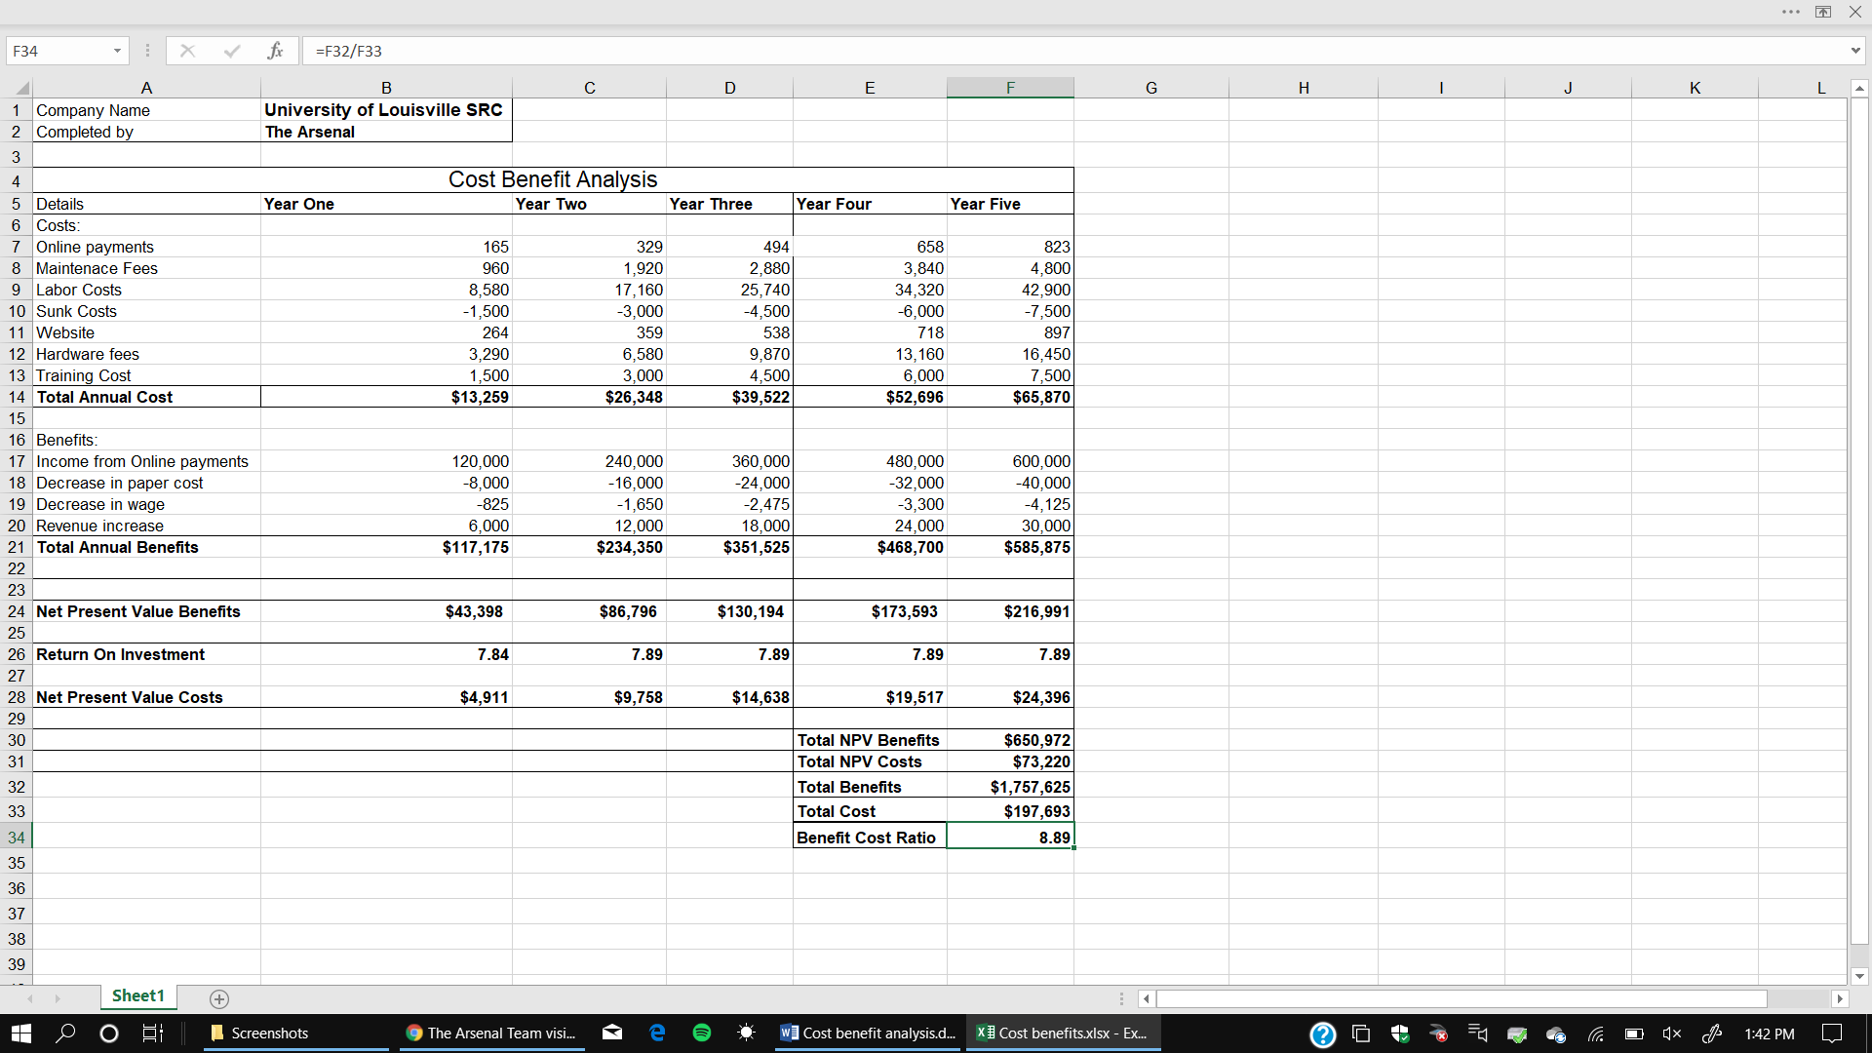

**Costs**

* **Online payments:** we estimate that roughly the SRC has an average of 500 people per week and multiply it by the online payment fee by each transaction.
* **Maintenance Fees:** According to Google a professional website takes about $80 per month to maintain it.
* **Labor cost:** we estimated that the majority of the fitness are students, so they are part-time which means they work about 20 hours a week. We took 20 hours by 52 weeks to give us the gross hours per year. Then we multiply by 8.25.

**Benefits**

* **Paper Cost:** According to the record national average annual cost to store documents in an office is about $8,000.
* **Income from Online payments:** Membership cost around $240 per year for members so took that and multiple it by people per year which was 500.
* **The decrease in Wage:** estimated that if the works worked two hours less and 2 hours shorted. We would multiply 2 hours by 50 weeks and by the amount they get paid hourly.
* **Revenue increase:** We took the year rate of $240 and multiply it by 25 new members as if the rate was to go up.
* **NPV:** Calculated by using the current inflation of 1.7% and using the total annual benefits/cost per year
* **ROI:** calculated by taking total annual benefits per year and subtracting it by total annual costs and then dividing it.
* **Benefit-Cost Ratio:** Calculated by taking total benefits and diving it by total costs.

**“As-is” process Model**

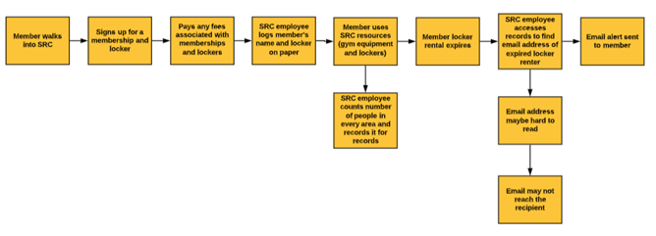

**“To-be” process Model**

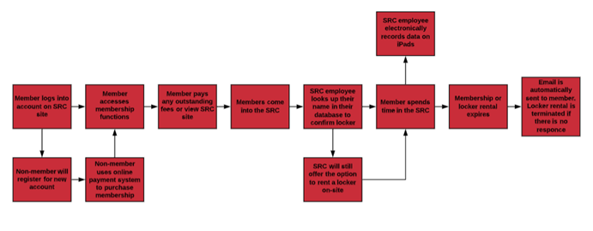

**System Requirements**

**Nonfunctional Requirements**

1. The new system will have a user interface.

2. The new system will be easy to use by all customers.

3. The new system will create an account in 5 seconds or less.

4. The new system will retrieve account information in 5 seconds or less.

5. The new system will operate on the University of Louisville servers/cloud systems.

6. The new system should backup information at the end of each day

7. The new system should have Two-factor authentication

8. The new system will have live updates

8.1. Hours of operations

8.2. Closings

8.3. Locations of operations- repairs or needing maintenance.

9. The new system will have similar password requirements as ULink.

10. The new system will delete inactive members.

**Functional Requirements**

1. Users can check membership status.

2. Users will be required to create an account.

3. Users can make payments online.

4. Users will be able to change a password or reset it.

5. Users will use the same email and password protocol as ULink.

6. The system will use PayPal for online payments.

7. Users can view weekly schedules.

8. Users can reserve equipment.

9. Users can contact the facility.

10. Users can register for Intramurals.

**Use Cases**

1. Create new members.

2. Delete members.

3. Login.

4. Sign up.

5. Forgot password.

6. Help.

7. Recover account.

8. Backup.

9. Manage membership.

10. Require Student ID.

11. Require student email.

12. Check weekly schedules.

13. Check the locker membership status.

14. Make purchases.

15. Make reservations.

16. Check facility activity.

17. Get email notifications.

18. Get email confirmations.

19. Suspend accounts.

20. Provide live updates.

21. Purchase lockers.

22. Provide security.

23. Provide contact information.

24. Provide staff information.

25. Provide intramurals information.

26. Secure online payments.

27. Provide a facility map.

28. Provide equipment locations.

29. Provide information on broken equipment.

30. Updated hours of operations.

**Trace Matrix**

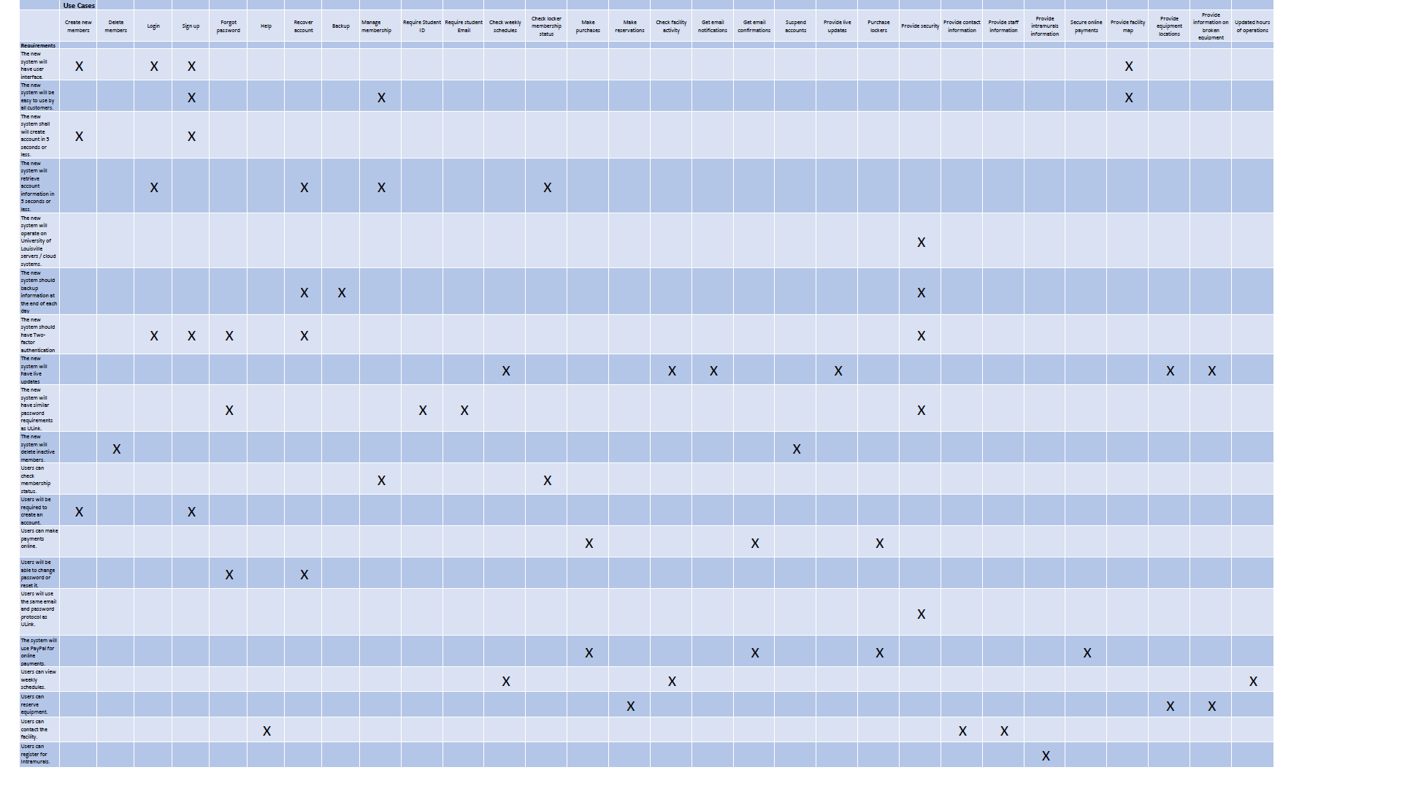

**Initial Architectural Considerations**

To provide the functionality that is recommended, there are several options to choose from. Items to how to host and update then back-end database to what equipment to purchase can be confusing and cost more than is necessary if not considered carefully.

In the past several years, advances in technology have made these kinds of decisions easier to make. What we suggest is this -

For initial database development, we suggest using Filemaker Pro, by Claris. FileMaker is a well used and recognized R.A.D. (rapid application development) software that can provide all of the functionality needed in a fraction of the time compared to traditional tools or software. It has the ability to easily interact with any web-based APIs, including PayPal. Other systems can exchange data easily through an industry-standard API that is included. The yearly licensing costs are lower than what a traditional enterprise database system would be and provide all the functionality that is needed for this project.

The inclusion of cloud-based storage and virtualization of servers has made it easier to decide on whether to purchase server equipment or use a hosting company. The average cost to purchase physical equipment is still lower overall than using a hosting company. But you will need to have a subject matter expert to maintain the system to avoid outside attacks, which is where the extra cost will override what a hosting company can provide. We suggest using the UofL’s IT services. They can create a virtual server quickly and for little cost overall. One of the best advantages of using their hosting service is that they are responsible for any operating system updates and overall security of whatever is being hosted. With this option, the only additional cost is to have occasional database maintenance, which our group can provide.

**Risk Analysis**

1. Create new members - Low Risk: a member doesn’t continue to be a member

To prevent: Add a delete member function

2. Delete members - Low Risk: there might be a human error such as a wrong member might be deleted

To prevent: Keep member info backed up

3. Login - High Risk: It is possible to have your information compromised and hacked

To prevent: Set a password requirement and require the password to be changed every 6 months

4. Sign up - High Risk: If you put someone else’s email or phone number in your account then he could access your account

To prevent: You could put a verification for phone and email when signing up

5. Forgot password - High Risk: User’s reuse their old password

To prevent: Require the password to be changed every 6 months

6. Help - Low Risk: Help function can’t be found easily

To prevent: Make help function easily accessible

7. Recover account. - High Risk: Different user might recover the account

To prevent: Verify the user before recovering the account

8. Backup. - High Risk: if the backup isn’t done correctly and half of the stuff isn’t backed up

To prevent: Check to see if everything is backed up correctly

9. Manage membership - Low Risk: if someone cancels their membership

To prevent: Admin user could redo their membership

10. Require Student ID - Low Risk: wrong student id could make data inaccuracies

To prevent: set a 7 digit requirement for student id

11. Require student email - Low Risk: a student could put a wrong email address

To prevent: verify the email

12. Check weekly schedules - Low Risk: weekly schedule could be changed due to some reason

To prevent: Update the schedule regularly

13. Check the locker membership status - Low Risk: locker membership status could be wrong

To prevent: Update the locker membership

14. Make purchases - High Risk: Credit card info could be stolen in between making purchase

To prevent: Take some security measures to prevent any hacking

15. Make reservations - Low Risk: student’s reservation might not be completed because of a glitch

To prevent: Send email confirmation to students for the reservation

16. Check facility activity - Low Risk: facility activity data could be incorrect

To prevent: Make sure to update facility activity data regularly

17. Get email notifications - Low Risk: email might not be received because of a system glitch

To prevent: tell members to always check if they received the notification

18. Get email confirmations - Low Risk: email might not be received because of a system glitch

To prevent: tell members to always check if they received the notification

19. Suspend accounts - Low Risk: if someone cancels their membership

To prevent: Admin user could redo their membership

20. Provide live updates - Low Risk: some updates aren’t updated correctly

To prevent: check if it’s updated or not after updating it

21. Purchase lockers - Low Risk: same lockers could be given to more than one people

To prevent: auto-assign different lockers to each members

22. Provide security - High Risk - security could be hacked

To prevent: take some security precautions to prevent hacking

23. Provide contact information - High Risk: incorrect contact information could be given

To prevent: verify if the contact information is correct

24. Provide staff information - Low Risk: incorrect staff information could be given

To prevent: verify if the staff information is correct

25. Provide intramurals information - Low Risk: Intramurals information could be outdated

To prevent: updated the information regularly

26. Secure online payments - High Risk: Online payments could lose connection midway of making payment and it could charge the customer but not give product

To prevent: Verify if the customer is charged or they received their product

27. Provide a facility map - Low Risk: Facility map could be incorrect

To prevent: update the facility map regularly

28. Provide equipment locations - Low Risk: Equipment locations could be incorrect

To prevent: update the equipment locations regularly on the website

29. Provide information on broken equipment - Low Risk: Broken equipment information could be incorrect

To prevent: update the broken equipment information regularly

30. Updated hours of operations - Low Risk: Hours of operations could be outdated

To prevent: update the hours of operation regularly on the website

**Team Charter**

Team Arsenal wants to provide the most cost-effective and high-level system. The system should a big improvement from its formal system. We want it to be an interesting concept so the client will interact with the system effortlessly and find the learning process a valuable input for their company. UofL is one of the best universities in Kentucky and one of the most famous universities, it functions at a high level. The system we are planning is one that will be compared to other universities in the nation so it must be a top-level system. We want it to be easy to use and a high function for the client’s customers and the client themselves.

The biggest problem most new systems have is a lack of management and a solid foundation. As a group, we are establishing a system that will function at a high level for as long as they deserve. We will provide maintenance guidelines for the client to follow so they can keep things in check and understand how the system functions. We also want the system to be a footprint for any changes in the future.

By changing nothing, nothing changes. We are not creating a new method for the SRC to run their business or asking to make extreme decisions concerning the system, the new system might require the client to make changes so the system could function properly. Some of the changes could be hiring staff with some technical experience with computing systems. The goals we have set for the system is to have a system that is an improved upgrade from the last system, the system is cost-effective and easily accessible by its users.

The Team will be meeting based on how the project progresses. The team meetings are not something will be having multiple times a week. The group is satisfied with online communication where we can ask and answer anytime. The team meeting will be meeting after class to see how each member is progressing with the task given to them. The team meeting will be announced in the online group chat. In the meeting, each member talks about how they are coping with the task they are assigned. Questions will be asked concerning any delay or missing tasks and solutions will be provided after the problem is discussed. The recorder writes down the tasks we need to do, any changes that need to be made, new information from the project manager, and provides details on how we can improve. All the information recorded is posted on the group chat. The topics that were not covered in the meeting is discussed in the group chat.

As a group we want to get everyone's opinions and decisions, the members decide on what seems reasonable to do and whether they will do it. Every member has their own input based on their experience or knowledge. After we have input all our thoughts and ideas into the project, the instructor will grade and evaluate to see if it reaches the requirement needed. The instructor provides reports, so we can make changes to improve our project. We contact the client to get their opinion and see if we can continue with the project. The instructor can also decide if the project is ready for the next phase.

Team decisions will be based on respect for everyone and the goal we set on achieving which is the project. Anything other than the project will be ignored or removed (this includes inactive group members). There is no leader in the group except the instructor that oversees all project. The members must be accountable for themselves, so they don’t but the project in an unfavorable situation for everyone including the client. Critical decisions will be made based on everyone's agreements. Conflicts will be resolved with respect and openness to change. Inactive members will be reported to the instructor.

The team documents the project on Google docs, where every member could make changes to any documents. A certain member will be selected to review all documents before its submitted or presented.

**Gantt Chart**

* Our Gantt chart shows the progression we have with our iterations. The chart below shows the progress with iterations one and two. We are currently finished with all portions of iteration two, so the chart will show 100% completion with both iterations.

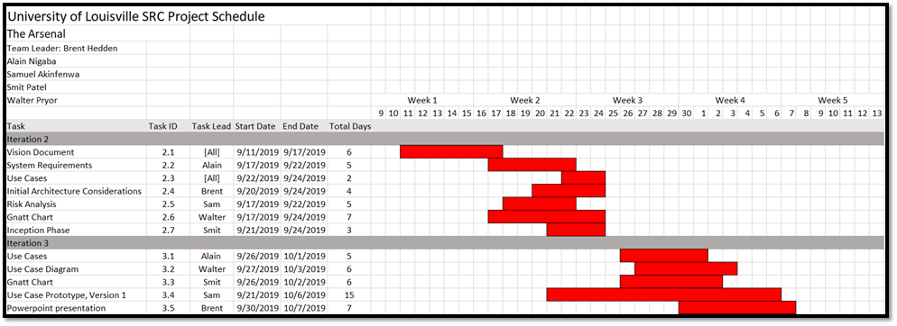

**Prototypes**

